
The Commonwealth of Massachusetts
Executive Office of Health and Human Services
Department of Public Health
250 Washington Street, Boston, MA 02108-4619

CHARLES D. BAKER
Governor
KARYN E. POLITO
Lieutenant Governor

MARYLOU SUDDERS
Secretary
MARGRET R. COOKE Commissioner

Tel: 617-624-6000
www.mass.gov/dph

May 11, 2022

Dear Provider:

We are writing to let you know about a new one-page Paxlovid Treatment Guide with the latest information about Paxlovid (nirmatrelvir/ritonavir), which continues to be the preferred treatment for most patients with mild-to-moderate COVID-19 infection. Paxlovid is in ample supply and widely available in Massachusetts.

We need your help to ensure that Paxlovid and other COVID-19 treatments are offered to all patients eligible to receive them. Any patient 12 years or older who tests positive for COVID-19 should be evaluated and prescribed Paxlovid or other treatment, as appropriate.

Patients may also use the Commonwealth’s new free Telehealth Service for COVID Treatment, available to anyone 18 years or older living in Massachusetts. The telehealth service is a quick, easy and free way for individuals to see if Paxlovid is an appropriate treatment for them. Each prescription is an opportunity to prevent severe disease. Please note:

- COVID-19 treatments should be considered for all your patients 12 or older and prescribed to all patients appropriate for treatment. This group includes over 40% of all MA residents eligible due to risk factors including those age >65, or with asthma, diabetes, heart, lung, liver, or kidney disease, cancer, disability, pregnancy, substance use disorder, mental health disorder, overweight/obesity, current/former smoker, or immunocompromise.
- COVID-19 treatments work best when given as early as possible in the course of illness – and Paxlovid and Molnupiravir must begin within five days of symptoms.
- PCR testing is not necessary – positive antigen tests (even those administered at home or school) are sufficient to prove infection and prescribe treatment.
- Massachusetts has supply available to meet the needs of all eligible residents.
- Treatments are widely available via retail pharmacies across the Commonwealth.
More information can be found here: MA COVID Treatment Information for Patients and Providers
FDA PAXLOVID Patient Eligibility Screening Checklist Tool

Thank you for your assistance and cooperation to provide these life-saving treatments to your patients.
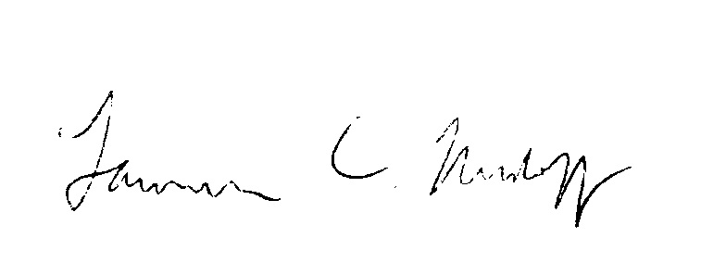
Larry Madoff, Medical Director
Bureau of Infectious Disease and Laboratory Sciences

Dylan Tierney, Associate Medical Director
Bureau of Infectious Disease and Laboratory Sciences
Massachusetts Department of Public Health

