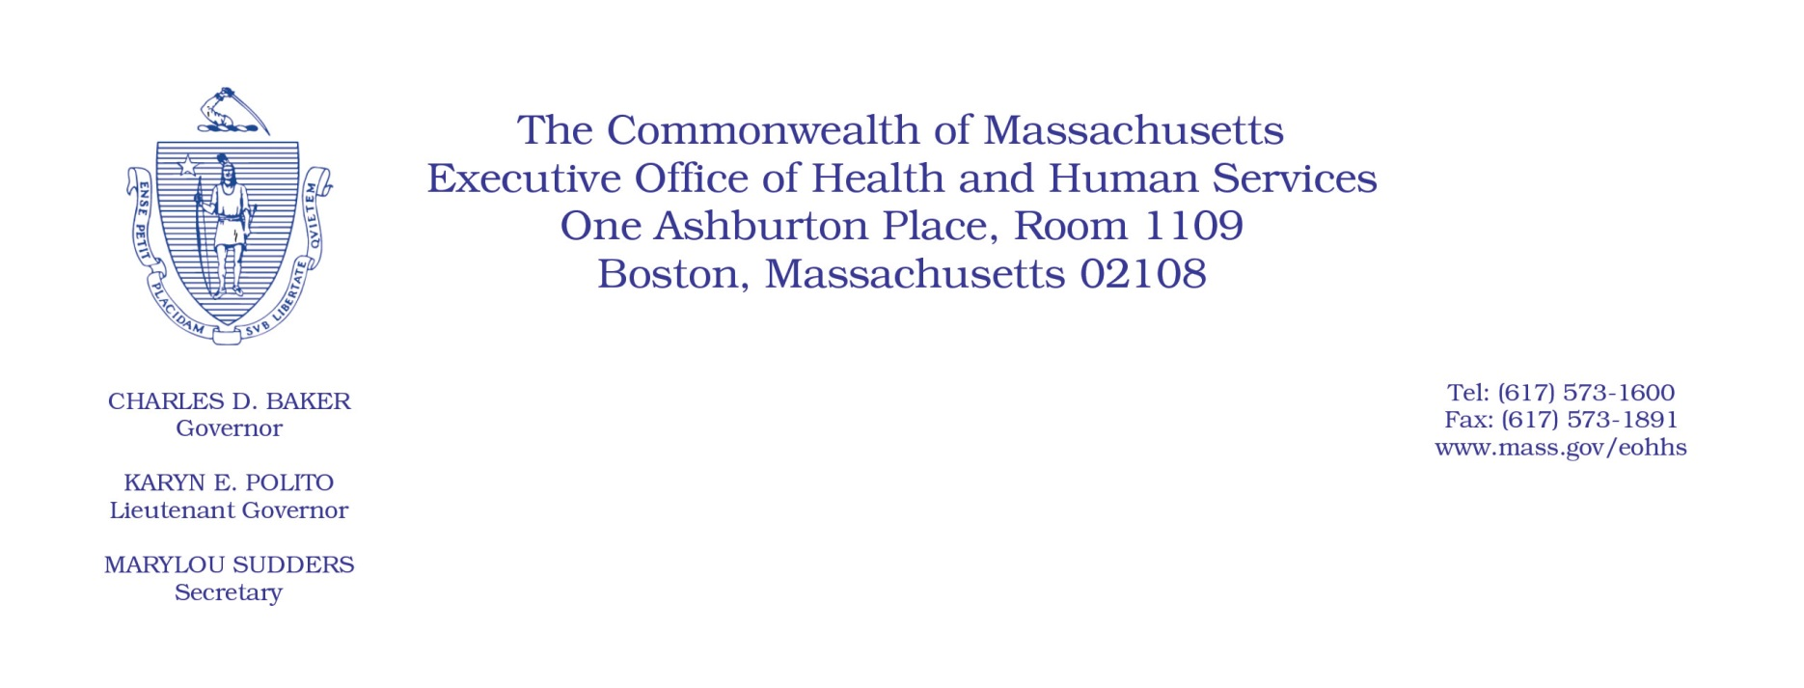

**TO:** Nursing Home Licensees

**FROM:** The Executive Office of Health and Human Services (EOHHS)

**SUBJECT**: Nursing Home Resident Bedroom 2-Bed Maximum Requirements

**DATE**: April 22, 2022

This communication serves as a reminder that, as required by the Department of Public Health (DPH) regulation105 CMR 150:000: *Standards for Long-Term Care Facilities*, **all long-term care facilities licensed by DPH must comply with the 2-bed maximum requirement on or before April 30, 2022.**

**Please be advised that** **any exceptional circumstances granted by MassHealth for density reduction requirements under MassHealth Nursing Facility Bulletin 154 have no bearing on the DPH 2-bed maximum requirement under 105 CMR 150.000.**

The DPH 2-bed maximum requirement under 105 CMR 150.000 is a Long Term Care facility licensure requirement that is separate and distinct from the MassHealth policy, and DPH may enforce its licensure requirements in accordance with DPH regulations. If, despite a licensee’s good faith efforts to comply with the 2-bed maximum requirement and through no fault on the part of the licensee, the licensee cannot fully comply with the 2-bed maximum requirement by April 30, 2022, the licensee may submit an attestation provided by the Department attesting to its good faith efforts towards compliance and expected date to come into compliance.

MassHealth Nursing Facility Bulletin 154 carried separate MassHealth-specific enforcement provisions, from which nursing facilities that were granted exceptional circumstances by MassHealth were exempt. Any waivers from DPH requirements, or approvals of attestations of good-faith efforts towards compliance with DPH requirements, must be submitted to DPH for consideration, regardless of whether the facility had been granted an exceptional circumstance by MassHealth under MassHealth Nursing Facility Bulletin 154.

**All nursing homes must comply with the DPH 2-bed maximum requirement or obtain a waiver from such requirements pursuant to 105 CMR 153.031 on or before April 30, 2022.**